SIMATSENGINEERING C03ASSESSMENTTOOL1
COURSE CODE: CSA1610 COURSE NAME: DWDM
D Bhavitha(192511152)

EXPERIMENTS

Q1RCodeforCovarianceandCorrelation: CODE:
@relationphoto_preference

@attributeAge_of_child{5-6,7-8,9-10} @attribute Photo_A numeric
@attributePhoto_Bnumeric @attributePhoto_Cnumeric

@data
5-6,18,22,20
7-8,2,28,40
9-10,20,10,40
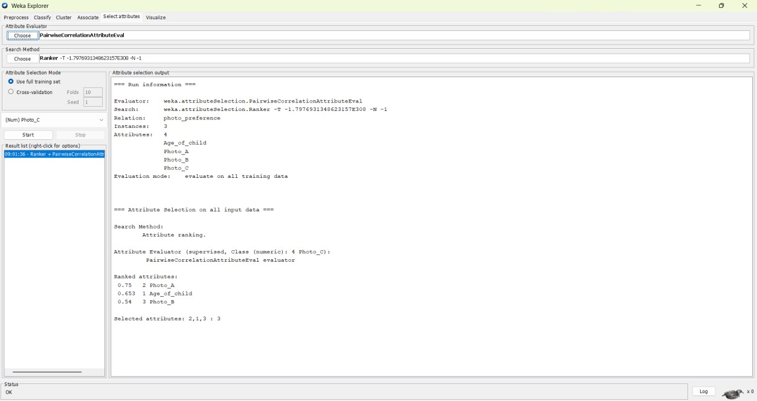

Q2RCodeforBoxplotandOutlierDetection CODE:
@relationtennis_scores

@attributePlayer_IDstring @attributePlayer_Namestring
@attributePoints_Scorednumeric

@data P1,Player_A,12 P2,Player_B,15 P3,Player_C,14 P4,Player_D,10 P5,Player_E,18 P6,Player_F,20 P7,Player_G,22 P8,Player_H,13 P9,Player_I,11 P10,Player_J,35 P11,Player_K,16 P12,Player_L,17 P13,Player_M,19 P14,Player_N,21 P15,Player_O,23

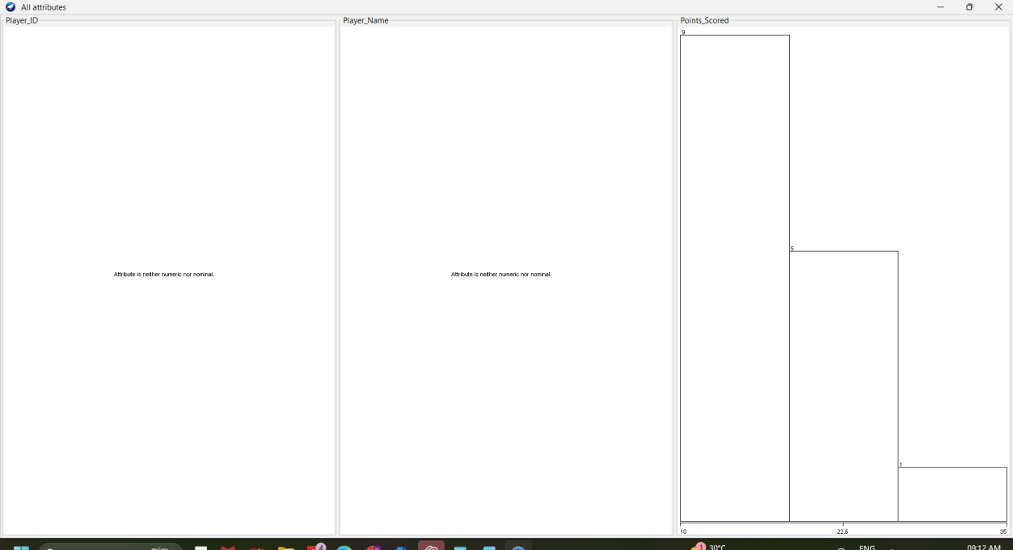

Q3RCodeforDecisionTreeClassifier CODE:
@relationloan_approval

@attributeAge{young,middle,old} @attributeIncome{low,medium,high}
@attributeEmployment_Status{employed,unemployed,self-employed} @attributeCredit_Score{poor,average,good}
@attributeLoan_Approval{yes,no}

@data
young,high,employed,good,yes young,high,self-employed,average,yes middle,high,employed,good,yes
old,medium,employed,good,yes old,low,unemployed,poor,no
old,low,self-employed,average,no middle,low,unemployed,poor,no

young,medium,employed,average,yes young,low,unemployed,poor,no
old,medium,self-employed,good,yes middle,medium,employed,average,yes middle,high,self-employed,good,yes old,medium,unemployed,poor,no
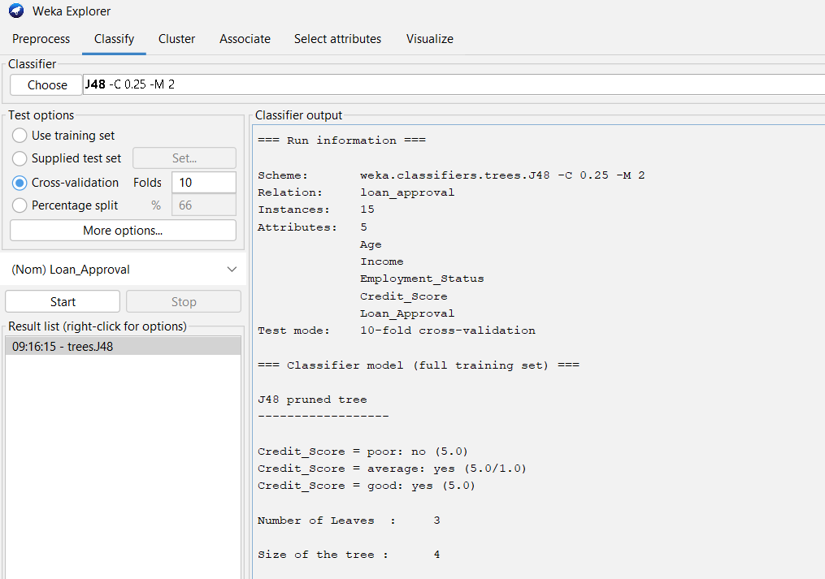
young,medium,self-employed,average,yes middle,low,employed,poor,no

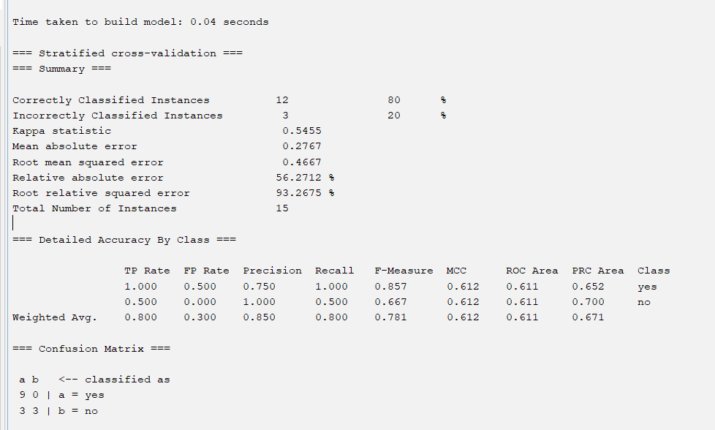

Q4RCodeforMean,Median,Range,andBoxplot CODE:
@relationexam_scores

@attributeClassAnumeric @attributeClassBnumeric

@data 76,51
35,56
47,84
64,60
95,59
66,70
89,63
36,66

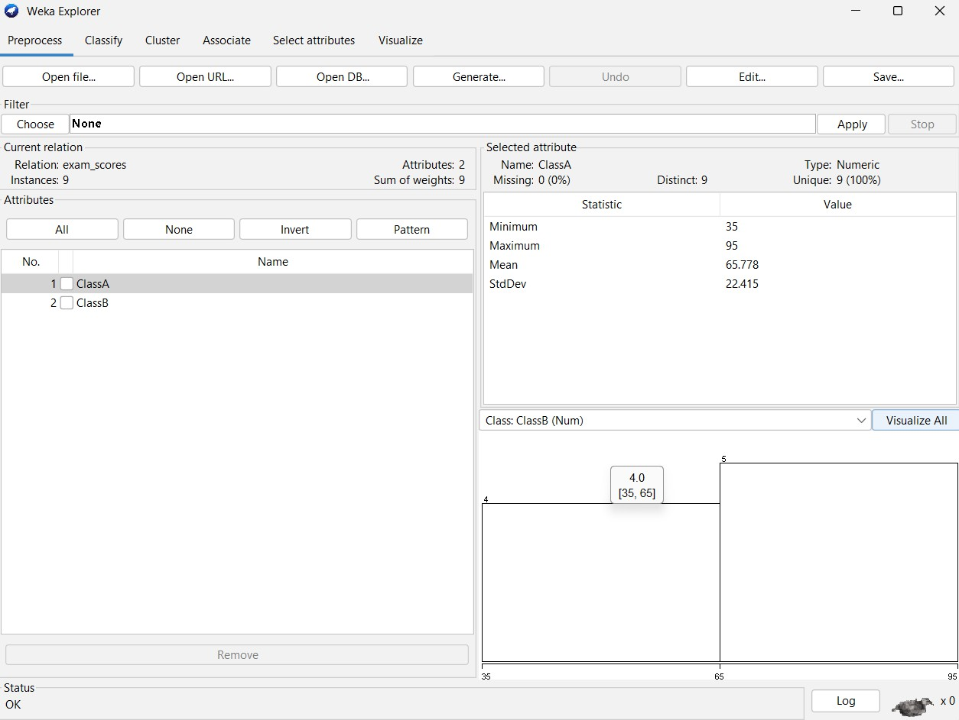
84,50

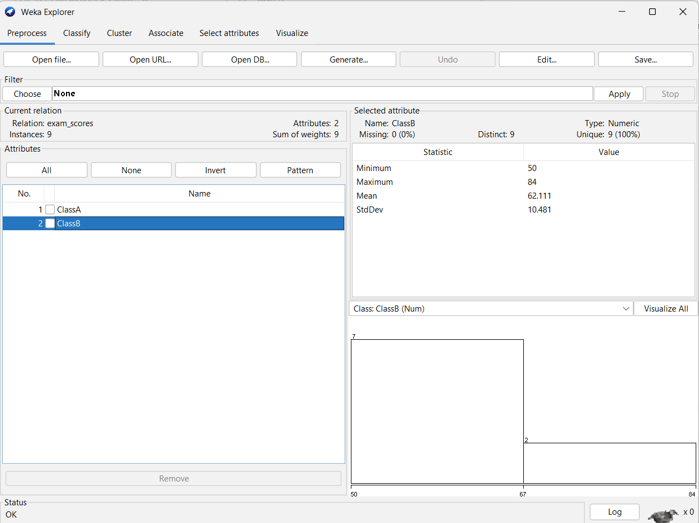
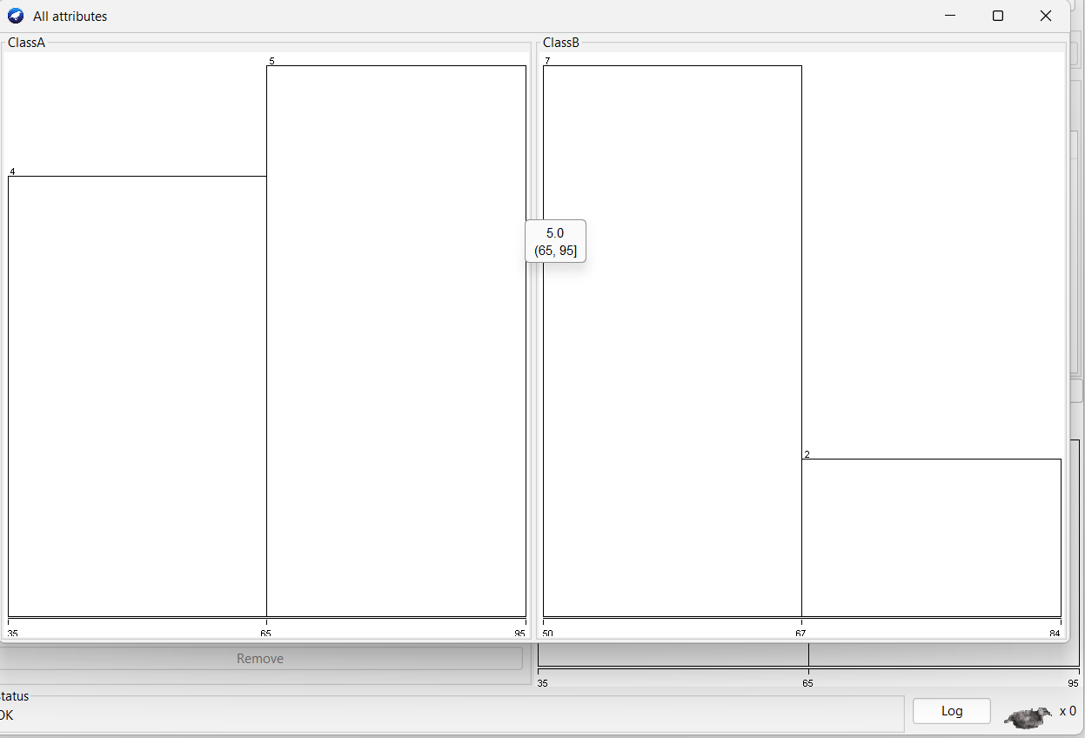

Q5RCodeforStatisticalAnalysis CODE:
@relationbodyfat_data

@attributeagenumeric @attributefatnumeric

@data 23,9.5
23,27.9
27,7.8
37,31.4
41,25.9
47,27.4
49,31.2
50,31.2
34,34.6
42.5,28.8
38,35.2
50,32.8
61,42.5
45,28.8
43,35.2
50,32.8
61,42.5
35.7,31.2

